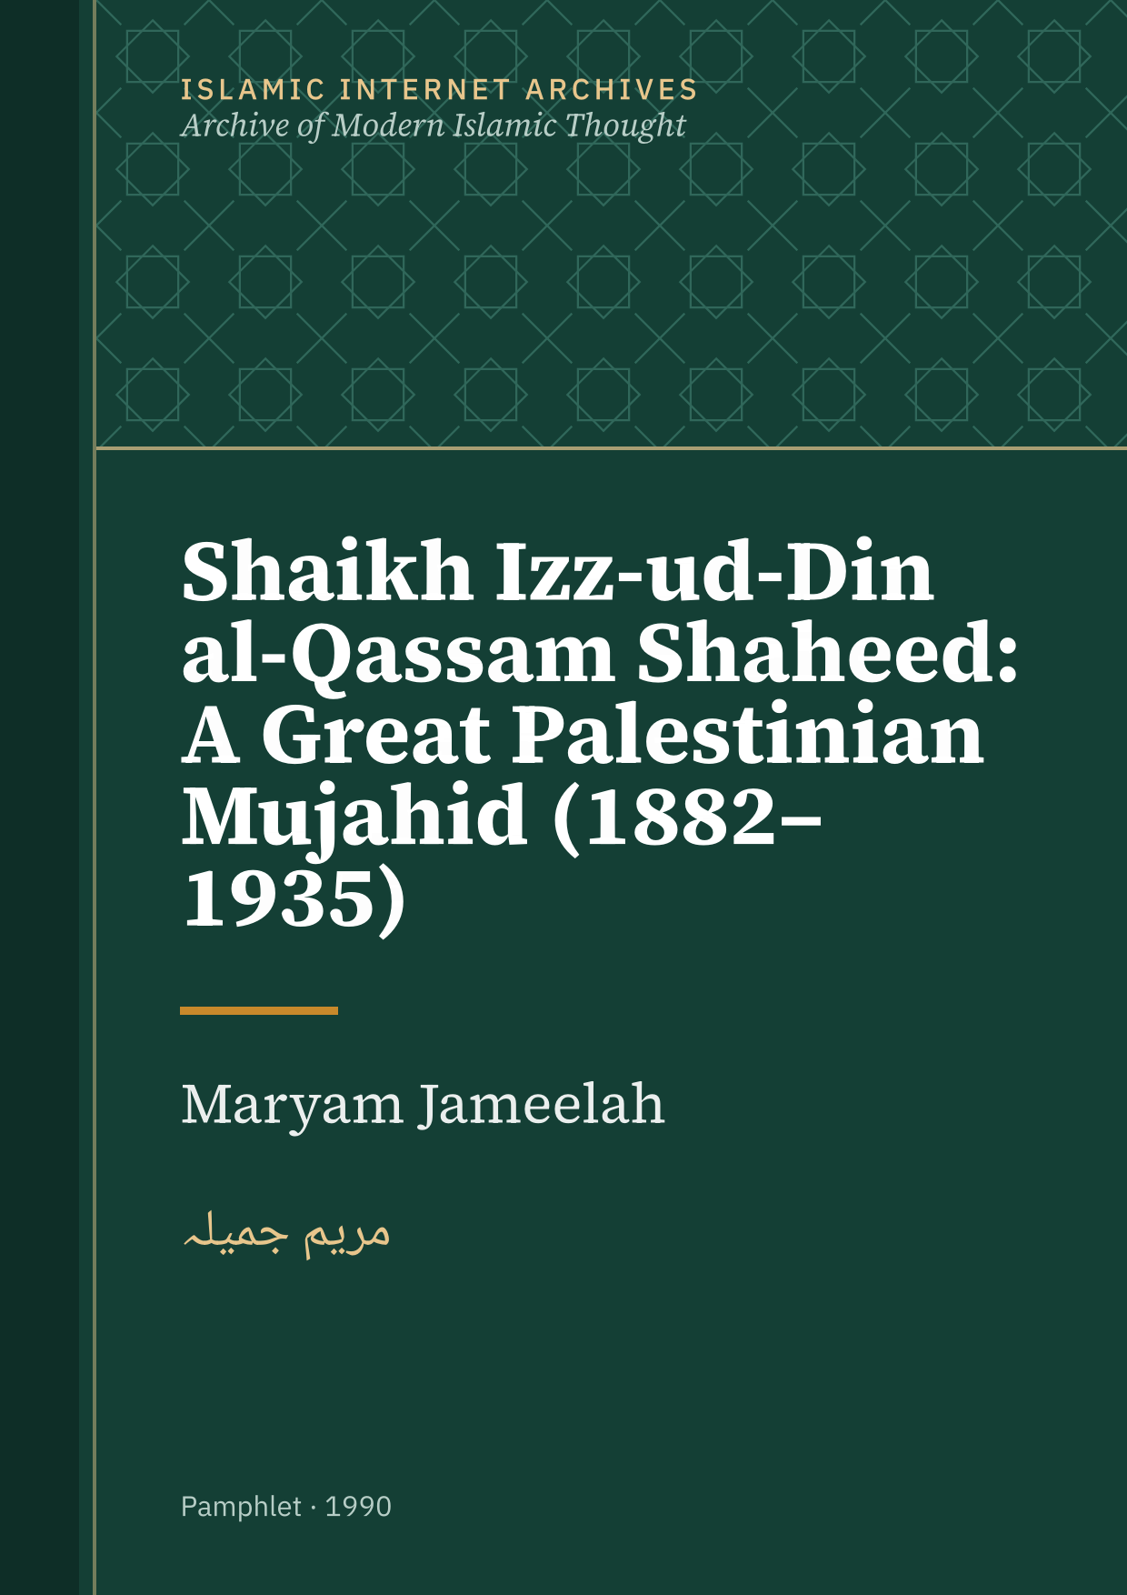

Shaikh Izz-ud-Din al-Qassam Shaheed: A Great Palestinian Mujahid (1882–1935)
Maryam Jameelah
مریم جمیلہ
1990

ISLAMIC INTERNET ARCHIVES
Archive of Modern Islamic Thought

About this edition
Title: Shaikh Izz-ud-Din al-Qassam Shaheed: A Great Palestinian Mujahid (1882–1935)
Author: Maryam Jameelah
Published in: Mohammad Yusuf Khan
First published: 1990
Rights: Published with permission of the rights holder; copyright remains with the owner. © Mohammad Yusuf Khan (publisher); free scan at Chughtai Library
Text quality: AI-tidied: Read from a scan, then tidied by AI. Not yet checked by a person: expect some errors.
Source: https://dl.chughtailibrary.com/files/repository/personal_collections/maryam_jameela/MJ8/Shaikh%20Izz-ud-Din%20Al-Qassam%20Shaheed%20A%20Great%20Palestinian%20Mujahid%20(1882-1935)%20His%20Lif%20and%20Work.pdf
Archived: 14 October 2026
Web page: https://islamicarchives.org/works/mj-shaikh-izz-ud-din-al-qassam-shaheed-a-great-palestinian-mujahid/
This file: Made on 4 November 2026 by islamicarchives.org from the archive's text. Corrections: use the Suggest a correction link on the web page.

Contents
Foreword
Shaikh Izz-ud-Din Al-Qassam Shaheed A GREAT PALESTINIAN MUJAHID
(1882 - 1935) His Life and Work

Foreword
1 Shaikh Izz-ud-Din Al-Qassam Shaheed A GREAT PALESTINIAN MUJAHID (1882 - 1935)

His Life and Work

BY

MARYAM JAMEELAH (formerly Margaret Marcus of New York)

Published by

MOHAMMAD YUSUF KHAN & SONS 15/49, Sunnat Nagar - Lahore (Pakistan) Telephone: 211448

2

Shaikh Izz-ud-Din Al-Qassam Shaheed A GREAT PALESTINIAN MUJAHID

3

(1882 - 1935) His Life and Work

BY

MARYAM JAMEELAH

(formerly Margaret Marcus of New York)

Published by

MOHAMMAD YUSUF KHAN & SONS 15/49, Sant Nagar - Lahore (Pakistan)

Telephone : 211448 4 ALL RIGHTS RESERVED

Copyright by Mohammad Yusuf Khan

1990 1st Edition

Price : Rs.

Printed at

EL-MABAAT UL-ARABIA 30 - Lake Road, LAHORE 5 Until the recent revolt of the Palestinians against Israeli military occupation, for several decades Palestinian leadership inside and outside of its occupied homeland, had passed over to the nationalists and secularists imbued with the alien ideology of Marxism.

Their inability to effectively resist the hostile forces of Zionist imperialism and colonialism had left the Palestinian resistance movement divided and impotent. So long as Palestine is regarded as a parochial Arab instead of a universal Islamic cause, the Palestinians will lack sufficient morale and support essential to achieve triumph. Only a genuine Jihad waged in conformity with the sacred Shar’iah and the Sunnah of the Holy Prophet (peace be upon him) can do this.

Tragically, most of the new generation of Palestinians in exile have been reared in total ignorance of their great Islamic heritage and its heroes. Contrary to what they have been misled to believe, Islam still lives and its heroes, far from being restricted to the distant past, have flourished as recently as the present century, inspiring their followers to this day.

Among contemporary mujahideen, Shaikh Izz-ud-Din al-Qassam Shaheed of Palestine occupies an honourable place. At a time when Hitler and Mussolini were waging an intense propaganda campaign to woo the Arabs until some of the Palestinian leadership had actually joined the Axis and were eagerly accepting “help” from Nazi Germany and Fascist Italy, Shaikh Izz-ud-Din waged Jihad against Zionism alone singlehanded, completely within his own resources.1

2 martyrdom in 1935, Shaikh Izz-ud-Din has been the subject of many Arabic biographers and historians as the symbol of Palestinian resistance.

Tragically, these sources have distorted his image in the worst betrayal of his memory by a complete omission of the spiritual dimensions of his life in contemptuous rejection of the Faith for which he lived and died.

Shaikh Izz-ud-Din was born in Jebla, a small village in the Latakia district of Syria in 1882 (1300 A.H.).

His father was a recognized master of Shar’iah under the Ottoman Turks while his mother was a direct descendant of the Holy Prophet. His grandfather and great-uncle were both prominent leaders of the Qaderi Sufi order and had migrated to Syria from Iraq. Al-Qassam, who followed the Hanafi school of jurisprudence, studied as a boy with a well-known Alim from Beirut who had settled in Jebla and taught Quran and Hadith at the local mosque. He was an excellent student. When he was fourteen at the turn of the century, he and his cousin were admitted into Al-Azhar University-Mosque in Cairo.

At that time, Shaikh Muhammad Abduh was its rector and there he also came into contact with Shaikh Rashid Rida but their modernist thought failed to be the decisive influence on the young student. In Egypt, he was brought into confrontation with both the British colonial forces as well as the modernist apologists among the country’s intellectuals.

Al-Azhar, the bastion of resistance against French and British colonialism, convinced Izz-ud-Din that the survival of Islam depended not upon words but deeds and that it was only through a genuine Jihad against the intruders that the Muslims could triumph over secularism and materialism.

Once Izz-ud-Din and a classmate found themselves desperately short of funds. Izz-ud-Din told his friend to cook a special Arab sweet-dish after which they would offer it for sale. When his friend’s father visited Cairo and was passing by Al-Azhar mosque, he found the boys selling the sweets on the 3 street. He asked his son why he was doing this and the boy answered: “This is what my friend told me to do.” The father replied: “He taught you to be self-sufficient.” Thus even at this early age, Izz-ud-Din practiced and encouraged self-sufficiency as one of the virtues combined with humility, courage and austerity for training in thabit (steadfastness) which was understood by his followers to mean the willingness to sacrifice and the practice of ethical conduct.

After studying for ten years at Al-Azhar, Izz-ud-Din returned as an Alim to his native village. Sensitive to the spiritual and material deterioration of the Muslims of his day, he was convinced that liberation from foreign domination could only be achieved by the revival of Islam.

At Jebla he taught at the local school run by the Qaderi Sufi order and preached at the village mosque. During this time, he became an adherent of the Tijania order and practiced tasawwuf but abandoned customary Sufi practices he suspected were not in strict conformity to Quran and Sunnah.

Izz-ud-Din never participated in the nationalist Arab movement but remained a loyal Ottoman subject. When the Italians invaded Libya in 1911 and at the outbreak of the first world war, Izz-ud-Din joined the Turkish army and insisted that he be given a military assignment where he also served as chaplain to the soldiers at the front.

When the Turks were defeated and the Ottoman empire collapsed, Izz-ud-Din became a leader of the guerilla bands who attacked the French forces and authorities in Syria. One by one the rebels were defeated through treachery and betrayal. King Faisal, who cooperated with the British and Zionists, simply handed over the guerillas to the enemy while Kemal Ataturk eliminated the remainder of the Syrian mujahideen by negotiating a deal with the French to make that region of Syria part of the new Turkish state.

4 In 1921, convinced that his arrest by the French was imminent, Shaikh Izz-ud-Din decided to migrate to Palestine and make his permanent home in Haifa, at that time a major refuge for Syrian exiles from French-occupied territories. Shortly afterwards, his wife and children joined him. Immediately after his arrival in Haifa, Shaikh Izz-ud-Din began to preach to the Palestinians the necessity for Islamic revival and Jihad. He taught at the city’s religious schools and preached tirelessly in the mosques. He constantly preached against Zionism in the strongest religious terms and directed his message to the poor and dispossessed.

At the mosques after his sermons, al-Qassam studied the men who seemed most deeply absorbed in their prayers, invocations and Dhikr and most responsive to his preaching and then began to visit them in their homes for more discussion and observation. Most of these men were illiterate railway, factory or construction workers, artisans or small shopkeepers. Many of them were former fellaheen or peasants displaced from their native villages by Zionist land-purchases.

Haifa epitomized all the combined effects of rapid industrialization and Zionist colonialism. As the major port, railway centre, and by the early 1930’s, oil refinery in the region, more than any other city in Palestine, Haifa attracted the emerging Palestinian working-class. The rapid increase in Jewish immigration from Europe created a construction boom which attracted more and more unskilled workers from the countryside.

Herded together into the most degrading and squalid slums and shantytowns, often separated from their families still remaining in the villages, the defenceless prey of a westernizing environment, these Palestinian workers resented the prosperous homes and streets built for and by the Jewish immigrant population, the experience often being driven from their places of work by Jewish pickets campaigning for exclusively Jewish 9 labour as well as the fact that the British mandate government paid the Jewish worker double the rate he received for the same labour. This was the human material al-Qassam chose for his disciples, convinced that their suffering increased their readiness for self-sacrifice because these impoverished people had nothing to lose and everything to gain.

Shaikh Izz-ud-Din taught his illiterate followers how to read, using the Quran as his textbook. From the same source, he taught them the doctrines of Jihad illuminated by Hadith which he quoted to them from memory.

Al-Qassam taught his men that the mujahid had been specially chosen by God and effective Jihad requires Ihsan - the sincere perfection of all aspects of Ibadat (worship) including creed, faith, and unquestioning submission to all of God’s commandments. The ideal mujahid helps the poor, feeds the hungry, comforts the sick, and visits his relatives often. All these good deeds must be accompanied by constant prayer and Dhikr (remembrance of Allah). Above all else, the mujahid must concentrate on his prayer (Salat) both obligatory and voluntary. Al-Qassam often quoted the Hadith describing Ihsan; “Worship Allah as though you are seeing Him and while you see Him not yet truly He sees you!”

The mujahid must practice tasawwuf or the purification of the heart by pursuing the greater Jihad against the baser self in man. In his public sermons at the mosques, he said that to be honest, truthful, respectful of others, their trust and family honour was Jihad.

To deprive oneself of sinful forbidden (haram) pleasures was Jihad and only when the Muslims had conquered their nafs or baser selves could they live in peace with themselves and their neighbours.

To the mujahideen, Shaikh Izz-ud-Din insisted that righteous character was more important than military bravery. A righteous man will never accept humiliation or defeat but will always 6 fight oppression. Therefore, the greater Jihad against the nafs takes precedence over the lesser military Jihad.

The mujahideen must fight fiercely because the enemy is the persecutor and they are the oppressed. In battle the mujahid must exert all his efforts to fight bravely and well. Even if he knows he is about to die, he is also certain that his martyrdom will be the inspiration for others to carry on the struggle until victory. Victory is certain because the enemy has only his love for life. Al-Qassam frequently quoted Quran and Hadith to show his men the eternal rewards which awaited the martyr in Paradise.

Al-Qassam taught his men the ninth Surah of the Quran, Surahat - Taubah entirely devoted to Jihad and after reciting the verse (IX : 6), gave strict orders to the mujahideen that if they captured any Jewish or British prisoners, they were not permitted to torture them. If there was a shortage of food, the prisoners must be fed first, even if it meant that the mujahideen would have to go hungry. He also forbade his men to mutilate the corpses of the fallen enemy.

In the training of his mujahideen, Al-Qassam was very strict and rigorous. One of them recalls; “He would take us for training and shooting lessons and order us to walk barefooted over rough terrain. He made us sleep out-of-doors in cold weather when we trained in the mountains. And he toughened us by making us go without food or water in order for us to be able to endure hunger and thirst.

He would also ask us to sleep once or twice a week at home on the cold hard floor on only a straw mat with a light cover and insisted that we be secretive about our activities so we were all in trouble at home with our wives and families because we could not explain to them why we were sleeping in this manner but we would endure this out of our devotion to obeying all his orders.”

Shaikh Izz-ud-Din instructed his mujahideen to carry a copy of Quran with them at all times so they could read and recite from it whenever they found themselves unoccupied. Al-Qassam 7 also told them to practice Dhikr and gave them simple invocations and chants to recite before undertaking any fighting.

There was nothing even his most illiterate disciples could not master. The light machine-gun was a mentality much more than a weapon, he used to say.

The Shaikh made no demands on his men in the matter of dress, insisting that the inward condition of their hearts was much more important than the condition of their clothes.

“The glory of the Muslims is Islamic rule”, was one of his favourite sayings which made it clear that in the advent of their victory, Palestine was to be an Islamic state.

Shaikh Izz-ud-Din was arrested and interrogated by the British police as many as four times, according to some reports, and told to stop his provocative activities. To counter this suspicion, Al-Qassam began to organize his men secretly. They were encouraged to return to their villages outside of Haifa either on regular visits or to resume residence in order to prepare the way for the induction of more recruits into the ranks of the mujahideen. Tirelessly Shaikh Izz-ud-Din traveled throughout the surrounding countryside urging the peasants and tribesmen to resist and fight.

In 1923, Shaikh Izz-ud-Din secured some land in the Beisan valley for farming in order to obtain the necessary source of income to purchase weapons for the Jihad as well as serving as a centre of communications with all parts of Palestine. In the summer he would come to Beisan to help plant the crops and in winter, accompanied by his men, he would visit neighbouring villages on horseback.

He gave strict orders to the mujahideen never to take nor ask for food in the villages unless the peasants gave it to them willingly.

The number of trained mujahideen rose to more than a thousand. Although the movement was strongest in northern Palestine around the vicinity of Haifa, al-Qassam eventually 8 managed to visit most of Palestine until he had disciples and secret circles throughout most of the countryside even as far south as Gaza.

The mujahideen started to attack Jewish settlements regularly in the attempt to discourage further Jewish immigration. Arab dealers who sold land to Jewish settlers were warned to leave the country. If they left, they would be unharmed but if they stayed and their dealings with the enemy continued,

Shaikh Izz-ud-Din would order his men to execute them as traitors.

In 1929, bloody Arab-Jewish riots broke out in Jerusalem after Zionists had hoisted their flag above the Wailing Wall. The loss of life and property was very heavy on both sides. Shaikh Izz-ud-Din forbade any of his mujahideen to take part in these riots.

He also condemned the 1929 massacre in Hebron (Al-Khalil) of orthodox Jews which he deplored as senseless chaotic violence and bloodshed. “Man is the brother of his fellow man,” he said, “whether he wants to be or not.”

Shaikh Izz-ud-Din had nothing but deepest distrust for the discordant Arab leadership who wanted to negotiate a “political settlement” with the British. To the very end, he remained convinced that only organized and well-trained armed resistance could stop the Judaisation of Palestine under British protection.

The British police began to search the homes of mujahideen for weapons and arrest them. Several were sentenced to long terms of imprisonment and one condemned to death. Shortly after that, Shaikh Izz-ud-Din decided to seek refuge in the hills surrounding Jenin and begin a full-scale guerilla war. But it was not long before his hiding place was discovered and surrounded by a large force of British police and soldiers. Called upon to surrender, al-Qassam told his men to die as martyrs and opened fire, killing one British soldier and injuring another. His defiance and the manner of his death electrified the Palestinian people and thousands forced their way past police lines to attend his funeral in Haifa.

9 On November 21, 1935, a three-column front-page headline story in The Jerusalem Post announced his death. Both in the headlines and in the body of the story, Shaikh Izz-ud-Din and his mujahideen were described as “notorious bandits.”

Five months later, several mujahideen, led by one of Qassam’s companions in the flight from Haifa, ambushed a group of Jewish travellers in northern Palestine.

In the weeks that followed, peasant guerilla bands and urban mujahideen sprang into action across the length and breadth of Palestine. The 1936-1939 Arab revolt convulsed the entire country until the British had all but lost control over the rural areas and even most of the urban centres at night. Only with the influx of thousands of British troops in cooperation with the Zionist Haganah, systematic aerial bombardment of Arab villages, the arrest, torture and execution of any Arab caught with weapons and the imprisonment and exile of almost the entire Palestinian Arab leadership, could the British finally crush the revolt three years later with an iron fist.

Shaikh Izz-ud-Din al-Qassam’s most enduring achievement was just in his being what has become so rare today - a true Muslim. He combined both the inner dimensions and the outward duties of Islam in perfect balance and in his own life harmonized contemplation with action.

His work for Islamic revival never stopped.

He always exhorted his people to practice all the teachings of Islam and to avoid everything contrary to Quran and Sunnah. To illustrate the theme of one of his sermons that a Muslim who fails to perform his Salat is spiritually dead, he once grabbed a villager who did not pray, had him placed in a coffin carried by his followers all around the village! This incident illustrates the Shaikh’s piety accompanied by a lively sense of humour.

All his followers, disciples, family and friends described Shaikh Izz-ud-Din as a warm, loveable person, always smiling and laughing. “Even during the worst times,” his wife recalled, 10 “he would always laugh and tell us there was nothing to worry about.” His family attributed his serene disposition to a complete faith and trust in 10 God.

One of his students in Haifa described him as a man with irresistible child-like charm. He laughed like a child and spoke with the simplicity of a child.

Both in his native Syrian village and later in Haifa, he lived with austere simplicity among the poor.

One Arab political leader not known for his sympathy for religion, who encountered Shaikh Izz-ud-Din al-Qassam several times during the last portion of his life, best lauded him in the following poem:

“His face was illuminated by an inner light.

Devoid of arrogance or egotism,

Open and available to all,

His people loved him

And he lived the life of a mujahid…”

This pamphlet is dedicated to the Palestinian youth both inside and outside Zionist-occupied territories in order that they may be inspired to reclaim their lost inheritance.

15

16

MARYAM JAMEELAH’S

Thought-Provoking Books on Islam

MARYAM JAMEELAH, born and reared in New York, embraced Islam in 1961 and migrated the following year to Lahore which is now her permanent home:

1. Islam Versus the West. 2. Islam and Modernism. 3. Islam in Theory and Practice. 4. Islam Versus Ahl al-Kitab: Western Imperialism Past and Present Menaces Muslims. 5. Ahmad Khalil: The Story of a Palestinian Refugee and his Family. 6. Islam and Orientalism. 7. Western Civilization Condemned by itself Vol. I Vol. II 8. Correspondence Between Maulana Maudoodi and Maryam Jameelah. 9. Islam and Western Society. 10. Islam Face to Face with the Current Crisis. 11. Why I Embraced Islam. Part I Part II 12. Islam and the Muslim Woman Today. 13. Islam and Our Social Habits. 14. Islamic Culture in Theory and Practice. 15. Three Great Islamic Movements in the Arab World of the Recent Past. 16. Who is Maudoodi? 17. Shaikh Hassan al-Banna and al-Ikhwan al-Muslimun. 18. A Great Islamic Movement in Turkey. 19. Shehu Uthman Dan Fodio: A Great Mujaddid of West Africa. 20. Two Mujahideen of the Recent Past and their Struggle for Freedom Against Foreign Rule. 21. Western Imperialism Past and Present. 22. Family Life in Islam. 23. The Generation Gap: Its Causes and Consequences. 24. Westernization Versus Muslims. 25. Westernization and Human Welfare. 26. Is Western Civilization Universal? 27. Modern Technology and the Dehumanization of Man. 28. Islam and Modern Man. 29. 30. The Resurgence of Islam and our Liberation from the Colonial Yoke. 31. Invitation to Islam, An open letter to My Parents. 32. 33. Memoirs of Childhood and Youth in America (1934 - 1962). 34. At Home in Pakistan (1962 - 1989). The Tale of an American Expatriate in her adopted Country.

PUBLISHERS:

Mohammad Yusuf Khan & Sons 15/49 SUNNAT (Sant) NAGAR, LAHORE-1 (PAKISTAN). PHONE: [^211][^448]

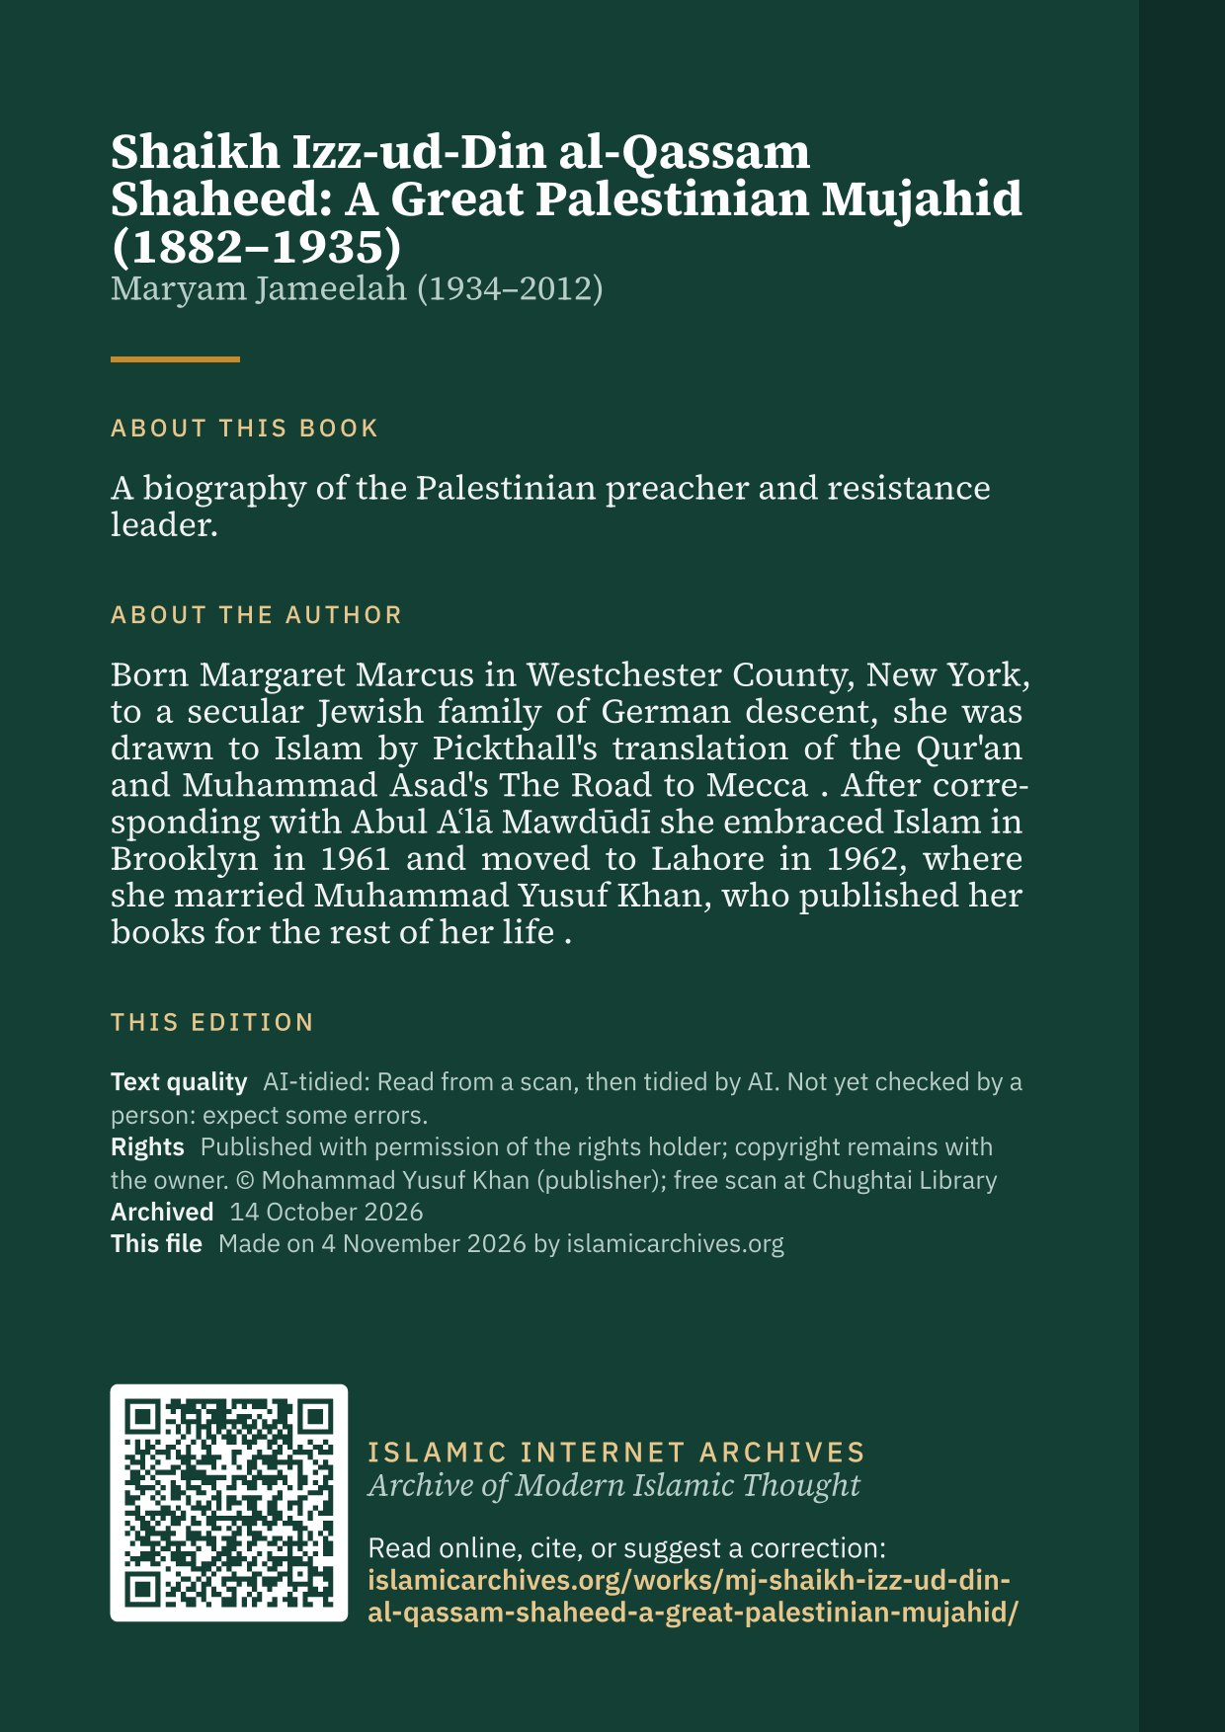

1 Most of the rifles for his fighters were purchased from the sale of their wives’ jewelry.
10 in

